**Annexure 1**

**Enrollment no:**

**190210116019____**



**NAME OF STUDENT: YASHKUMAR DEVRAJBHAI DONDA_______________________________________**

**DIARY OF THE WEEK: Dt: 23/01/2023 TO 27/01/2023 F**

**DEPARTMENT: INFORMATION TECHNOLOGY SEM: 8TH ­­­­­­­­­­­­­­­­_______ _________________________**

**NAME OF THE ORGANISATION: TATVASOFT__________________________________________________ NAME OF THE PLANT/SECTION/DEPARTMENT: FRONTEND ________________________________**

**NAME OF OFFICER INCHARGE OF THE PLANT/SECTION/DEPARTMENT :_MS. SWEETY PATEL___**

On the first day of work, we gathered at the community hall of company and each got assigned to respected instructors – who will guide during whole internship. I was instructed to go through the company website and training portal. Then study HTML from W3Schools.

On the second day, I was instructed to study and learn CSS from W3Schools Website. Later on, the mentor asked few questions related HTML and CSS.

On the third day, Company provided sessions on HTML / CSS and Assignments from that video sessions. I watched videos on started implementation as suggested in Assignment-1.

On the fourth day, Completed Assignment-1 and started next video about Assignments and started working on Assignment 2.

**DESCRIPTION OF THE WORK DONE IN BRIEF**

# 

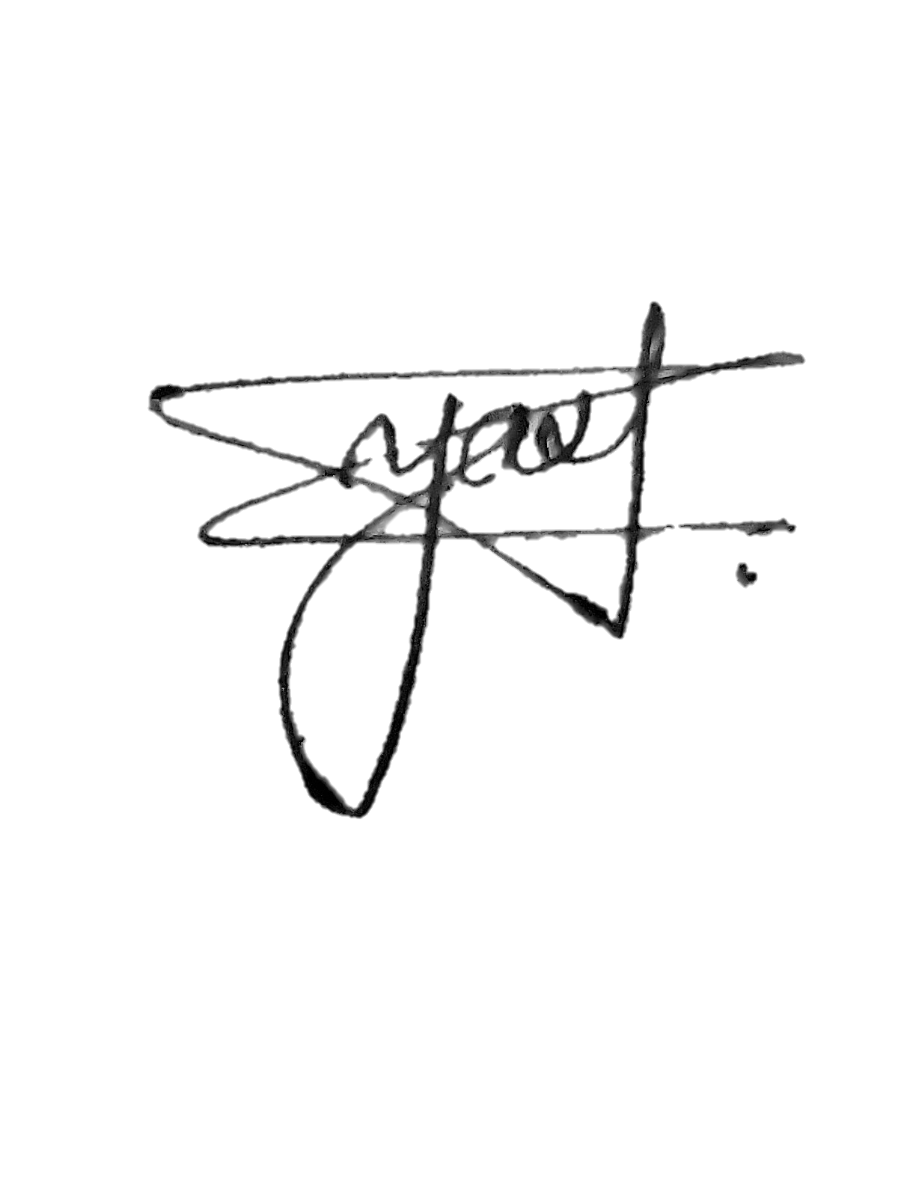

27/01/2023

27/01/2023

34 hrs.



**TOTAL**

**HOURS:**



**SIGNATURE**

**OF**

**STUDENT**



**The**

**above**

**entries**

**are**

**correct**

**and**

**the**

**grading**

**of**

**work**

**done**

**by**

**Trainee**

**is**

**EXCELLENT**

**/**

**VERY**

**GOOD**

**/**

**GOOD**

**/**

**FAIR**

**/**

**BELOW**

**AVERAGE**

**/**

**POOR**



**Signature of**

**Faculty**

**Mentor**



**Signature of officer**

**-**

**in**

**-**

**charge**

**of**

**Dept. / Section /**

**Plant**



**Date:**



**Date:**



**Grading of Work, for**

**trainee may be**

**given depending upon your judgement about**

**his**

**Punctuality,**

**Regularity,**

**Sincerity,**

**Interest**

**taken,**

**Work**

**done**

**etc.**